✅ append() Method in StringBuffer (Correct Notes)
• append() is an overloaded method in StringBuffer.
• Method overloading means:
- Method name is the same
- Arguments (parameter types) are different

✅ Commonly Used append() Method Signatures
public StringBuffer append(int i)
public StringBuffer append(long l)
public StringBuffer append(boolean b)
public StringBuffer append(double d)
public StringBuffer append(float f)
public StringBuffer append(char c)
public StringBuffer append(String str)
public StringBuffer append(Object obj)
✅ append() and Method Chaining
• All append() methods return the same StringBuffer object,
which allows method chaining.

🔹 What is method chaining?
Method chaining means:
- Calling multiple methods one after another
- On the same object
- In a single statement

🔹 Example
StringBuffer sb = new StringBuffer();

sb.append("Hello")
.append(" ")
.append("World")
.append(" ")
.append(2026);

System.out.println(sb);
Output
Hello World 2026

🧠 Why does this work?
- Each append():
  - Modifies the same StringBuffer object
  - Returns that same object reference
Internally, it works like:
sb.append("Hello") // returns sb
.append(" ") // returns sb
.append("World"); // returns sb
So the next append() is called on the same object.

🔑 Important Point
- ❌ No new StringBuffer object is created
- ✅ Same object is reused
- ✅ Improves readability and performance
✅ append() – Automatic Conversion Explanation
👉 When you pass int, long, boolean, double, float, char, or object to append(),
👉 Java automatically changes that value into text (String form),
👉 You do NOT need to convert it yourself.

🔹 Example
StringBuffer sb = new StringBuffer("Data: ");

sb.append(10); // int → "10"
sb.append(' ');

sb.append(true); // boolean → "true"
sb.append(' ');

sb.append(45.6); // double → "45.6"
sb.append(' ');

sb.append('A'); // char → "A"

System.out.println(sb);
Output
Data: 10 true 45.6 A

🧠 What happens internally (Simple idea)
- append(10) → converts 10 to "10"
- append(true) → converts true to "true"
- append(45.6) → converts 45.6 to "45.6"
- append('A') → converts 'A' to "A"
Java does this internally, like:
append(String.valueOf(value));

⭐ FINAL NOTE (FOR EXAMS)
append() accepts many data types and automatically converts them into String before appending.

• No new StringBuffer object is created during append()

Eg: StringBuffer_Append

✅ Common insert() Method Signatures
public StringBuffer insert(int index, int i)
public StringBuffer insert(int index, float f)
public StringBuffer insert(int index, long l)
public StringBuffer insert(int index, double d)
public StringBuffer insert(int index, boolean b)
public StringBuffer insert(int index, Object o)
public StringBuffer insert(int index, String str)

🧠 Important Rules (Very Simple)
- index starts from 0
- Valid index range: 0 to length
- Data at and after the index is shifted to the right
- Values of all data types are automatically converted to String
- No new StringBuffer object is created
insert() places data at a given index by converting it to text and shifting existing characters to the right.
Eg: StringBuffer_Insert_Method

✅ delete() and deleteCharAt() Methods in StringBuffer
🔹 delete(int begin, int end)
public StringBuffer delete(int begin, int end)
• Deletes characters starting from index begin up to index end - 1
• begin index is inclusive
• end index is exclusive
• Remaining characters are shifted to the left
• Returns the same StringBuffer object

🔹 deleteCharAt(int index)
public StringBuffer deleteCharAt(int index)
• Deletes the character at the specified index
• Index starts from 0
• Remaining characters are shifted to the left
• Returns the same StringBuffer object

Eg: StringBuffer_Delete_Eg37
// go through the code

public StringBuffer reverse()
Eg:StringBuffer_Reverse_Eg38
// go through the code

public StringBuffer setLength()
Eg: StringBuffer_Set_Length_Eg39
🧠 CORE POINTS (VERY IMPORTANT)
- setLength(int n) directly sets the length of the StringBuffer
- If n < current length → extra characters are truncated
- Index considered is 0 to n - 1
- Same StringBuffer object is modified
- No new object is created

public void trimToSize()
Eg: StringBuffer_trimToSize()_Eg40
// go through the code

public void ensureCapacity(int capacity)
✅ ensureCapacity() – Core Notes
• Default initial capacity of StringBuffer is 16.
• ensureCapacity(int minCapacity) ensures that the capacity is at least minCapacity.
• If minCapacity is less than or equal to the current capacity, no change occurs.
• If minCapacity is greater than the current capacity, capacity is increased using the formula:
new capacity = (current capacity + 1) * 2
• ensureCapacity() works based on the current capacity, not on the constructor value.
• No new StringBuffer object is created; only internal storage is expanded.
• Capacity never reduces automatically using ensureCapacity().

⭐ One-Line Remember Rule
ensureCapacity() increases capacity only when needed and never creates a new object

Eg: StringBuffer_ensureCapacity_Eg41

✅ String vs StringBuffer vs StringBuilder
(When to use, real-world usage, and problems)

🔹 1️⃣ String
✔ What it is
- String is immutable
- Once created, its content cannot be changed
✔ When to use
Use String when the content is fixed or does not change frequently.
✔ Real-world usage
• User name
• Email ID
• Country name
• URL
• Configuration values
• Keys in HashMap
• Constants
Example:
String country = "India";
String email = "abc@gmail.com";
❌ Problem if used wrongly
If you change strings frequently:
String s = "Hello";
s = s + " World";
s = s + " Java";
👉 Many new objects are created
👉 Performance becomes slow
👉 More memory waste

🔹 2️⃣ StringBuffer
✔ What it is
- StringBuffer is mutable
- It is thread-safe (methods are synchronized)
✔ When to use
Use StringBuffer when:
• Content changes frequently
• Multiple threads access the same object
• Data safety is more important than speed
✔ Real-world usage
• Banking applications
• Financial transactions
• Shared logs
• Multi-threaded server applications
Example:
StringBuffer sb = new StringBuffer("Balance: ");
sb.append(5000);
❌ Problem if used wrongly
• Slower than StringBuilder
• Synchronization causes performance overhead
• Not suitable for single-threaded applications

🔹 3️⃣ StringBuilder
✔ What it is
- StringBuilder is mutable
- It is NOT thread-safe
✔ When to use
Use StringBuilder when:
• Content changes frequently
• Application is single-threaded
• High performance is required
✔ Real-world usage
• Loops
• Building large strings
• Data processing
• File reading/parsing
• Backend logic (single thread)
Example:
StringBuilder sb = new StringBuilder();
sb.append("Hello");
sb.append(" World");
❌ Problem if used wrongly
• Not safe in multi-threaded applications
• Data inconsistency may occur
• Race conditions possible

🔁 Quick Comparison Table
Feature | String | StringBuffer | StringBuilder
Mutable | ❌ No | ✅ Yes | ✅ Yes
Thread-safe | ✅ Yes | ✅ Yes | ❌ No
Performance | ❌ Slow (if modified) | ⚠ Medium | 🔥 Fast
Memory | Efficient | Uses Heap | Uses Heap
Best use | Fixed text | Multi-thread | Single-thread

🏁 FINAL REAL-WORLD RULE (REMEMBER THIS)
Fixed text → String
Changing text + multi-thread → StringBuffer
Changing text + single-thread → StringBuilder

Eg: Method_Chaning_Eg42
✅ Method Chaining – Core Notes
• Method chaining means calling multiple methods in a single statement, one after another.
• Method chaining is possible only when each method returns an object reference.
• The returned object from one method becomes the calling object for the next method.
• In String:
- Methods return new String objects (because String is immutable)
- Chaining works, but new objects are created
• In StringBuffer / StringBuilder:
- Methods return the same object reference
- Chaining modifies the same object
- No new object is created
• Method chaining improves:
- Code readability
- Compactness
- Fluent style programming

⭐ One-Line Remember Rule
Method chaining works when methods return an object, allowing the next method call on that object.

Eg: Copy_Of_String_Eg43
// go through the code

Eg: Capital_String_Eg44
// go through the program.

Eg: SmallerCase_String_Eg45
// go through the program

Eg: Opposite_Case_Converting_Eg46
// go through the program

Eg: Reverse_The_String_Eg47
// go through the program

Eg: Word_Palindrome_Eg48
// go through the code

Eg: String_Eg49
// go through the program

Eg: String_Eg50
// go through the program

Eg: String_Eg51
// go through the program

Eg: String_Eg52
🔑 CORE POINT (MEMORIZE THIS)
s1 = s2;
➡ RHS is evaluated FIRST
➡ The value of RHS is assigned to LHS

What is the “value” here?
- s2 is a reference variable
- Its value is a memory address (reference)
So internally Java does:
s1.reference = s2.reference;

What happens because of this?
- s2 → ❌ NOT changed
- s1 → ✅ overwritten
- ❌ No object is copied
- ❌ No new object is created
- ✅ Both references now point to the SAME object

🔁 One-Line Interview Answer
In s1 = s2, Java evaluates the RHS first and assigns its reference value to the LHS. Only the LHS changes.

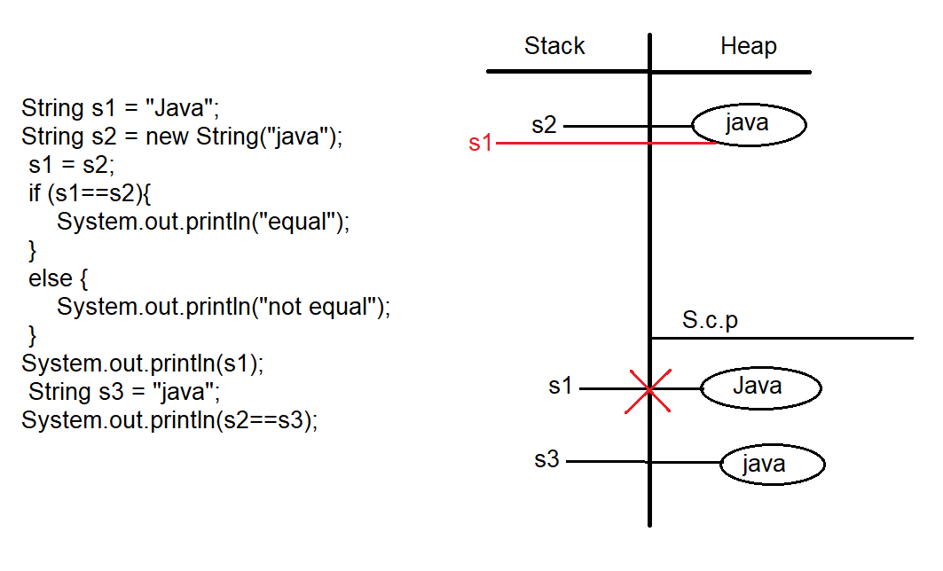

Eg: String_Eg53
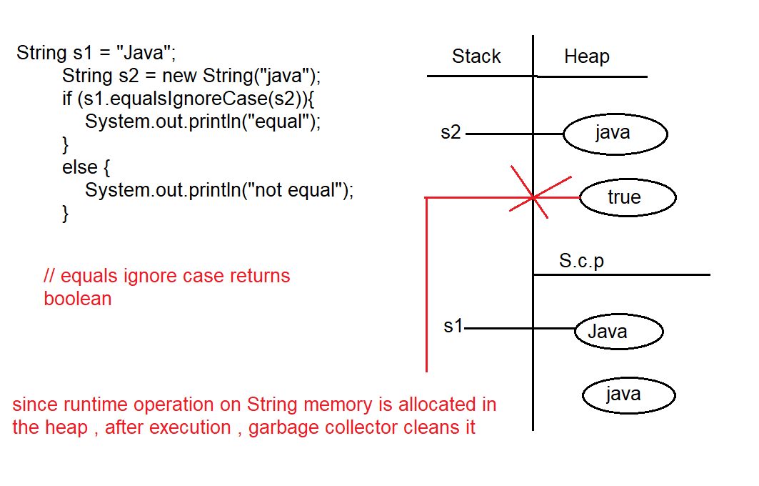

Eg: String_Eg54
// go through the code

Eg: String_Eg55
// go through the code

Eg: String_Eg56
// go through the program

Eg: String_Eg57
// go through the program

Eg: String_Eg58
// go through the code

Eg: String_Eg59
// go through the code

Eg:String_Eg60
// go through the code

Eg: String_Eg61
// go through the code

Eg: String_Eg62
// go through the code

Eg: String_Eg63
// go through the code

Eg:String_Eg64
// go through the code

Eg: String_Eg65
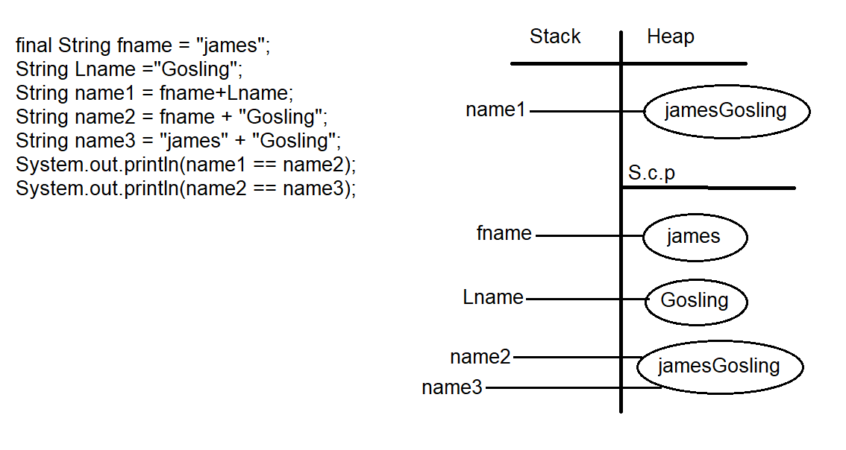

Only string literals and final variables with compile-time constant values are evaluated during compilation; everything else is evaluated at runtime ( discussed earlier)

Eg: Palindrome_Using_String_Methods
// go through the code

Eg: Converting _String_To_Char_Array
// go through the program

Eg: Anagram
📝 Anagram — Short Note
An anagram is a word or phrase formed by rearranging the letters of another word or phrase,
using the same characters exactly once.
- Spaces are usually ignored
- Letter case is usually ignored
✅ Examples
- listen → silent
- a gentle man → elegant man
- race → care

Eg: panagram
📝 Pangram — Short Note
A pangram is a sentence that contains every letter of the English alphabet (A–Z) at least once.
✅ Example
“The quick brown fox jumps over the lazy dog”
✔ This sentence contains all 26 letters from a to z.
❌ Not a Pangram
“Hello world”
(Does not contain all letters)

Eg: String_Eg66
// go through the code

Eg: String_Eg67
// go through the code

Eg: String_Eg68
// go through the code

Eg: String_Eg69
// go through the code

Eg: String_Eg70
// go through the code

Eg: String_Eg71
🧠 Key Rules (Perfect for Notes)
- String.join() → delimiter + non-null elements only
- delimiter must NOT be null
- Any null element → NullPointerException
- String.join("-", "a", "b") → works
- String.join("-", null) → ❌ error

Eg: String_Eg72
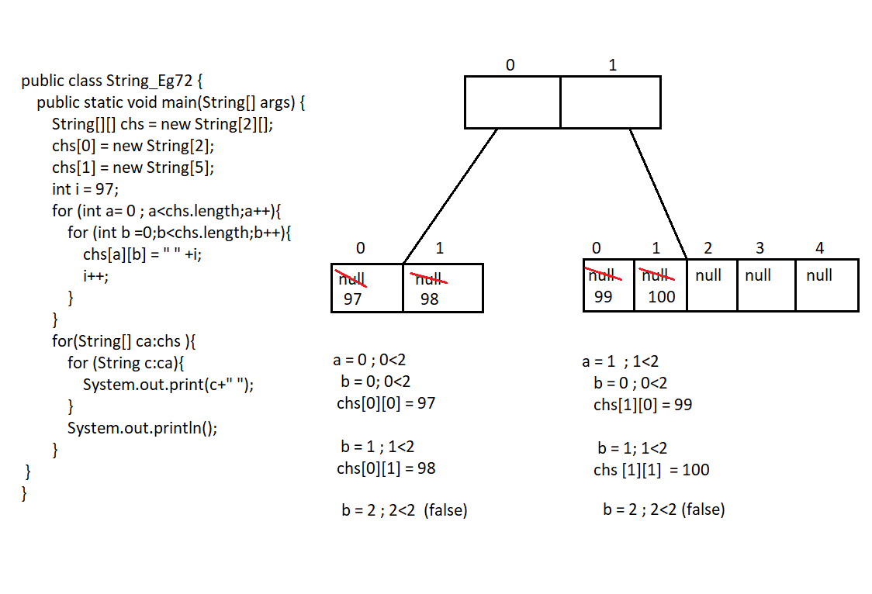
🧠 Step 1: Understanding the Array Structure
String[][] chs = new String[2][];
This creates:
- 2 rows
- Column sizes NOT decided yet
Then:
chs[0] = new String[2]; // row 0 → 2 columns
chs[1] = new String[5]; // row 1 → 5 columns
So the array looks like this:
Row 0 → [ ?, ? ]
Row 1 → [ ?, ?, ?, ?, ? ]
This is called a jagged array (rows have different sizes).

🧠 Step 2: Value of i
int i = 97;
97 is important because:
'a' = 97 (ASCII)
But here you are storing numbers as strings, not characters.

🧠 Step 3: The TRICKY PART (Nested Loops)
for (int a = 0; a < chs.length; a++) {
for (int b = 0; b < chs.length; b++) {
chs[a][b] = " " + i;
i++;
}
}
🔴 The hidden issue is HERE:
b < chs.length
- chs.length = 2 (number of rows)
- But column size is different for each row
So inner loop runs only 2 times, even for row 1 (which has 5 columns).

🧠 Step 4: What Actually Gets Filled
Row 0 (size = 2)
b = 0 → chs[0][0] = " 97"
b = 1 → chs[0][1] = " 98"
Row 1 (size = 5)
b = 0 → chs[1][0] = " 99"
b = 1 → chs[1][1] = " 100"
❌ Columns 2, 3, 4 of row 1 are never assigned
➡ They remain null

🧠 Final Array State
Row 0 → [" 97", " 98"]
Row 1 → [" 99", " 100", null, null, null]

🖨 Output
97 98
99 100 null null null

Eg: String_Eg73
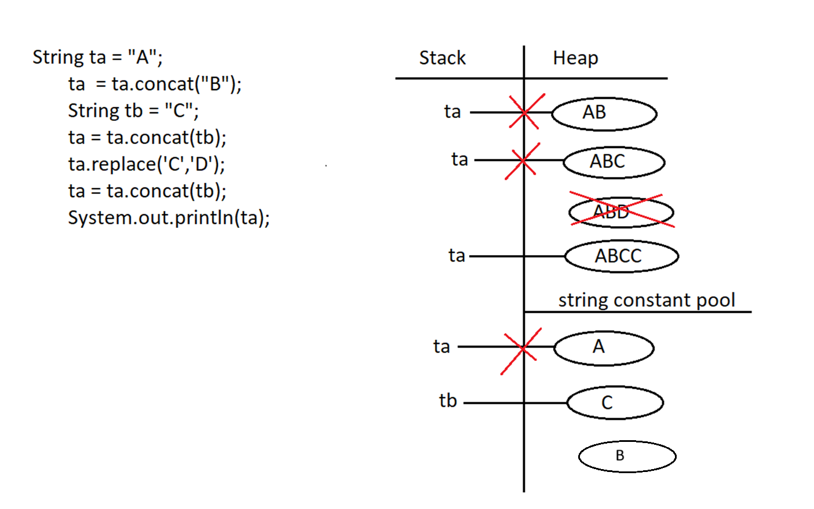

Eg: String_Eg74
// go through the code

Eg: String_Eg75
// go through the code

